Q 3: Scan & Find out Port Numbers open 203.163.246.23

Ist- Open Trerminal in Kali linux Machine.

2nd- Type “nmap -Pn -p1-6553 202.163.243.23”
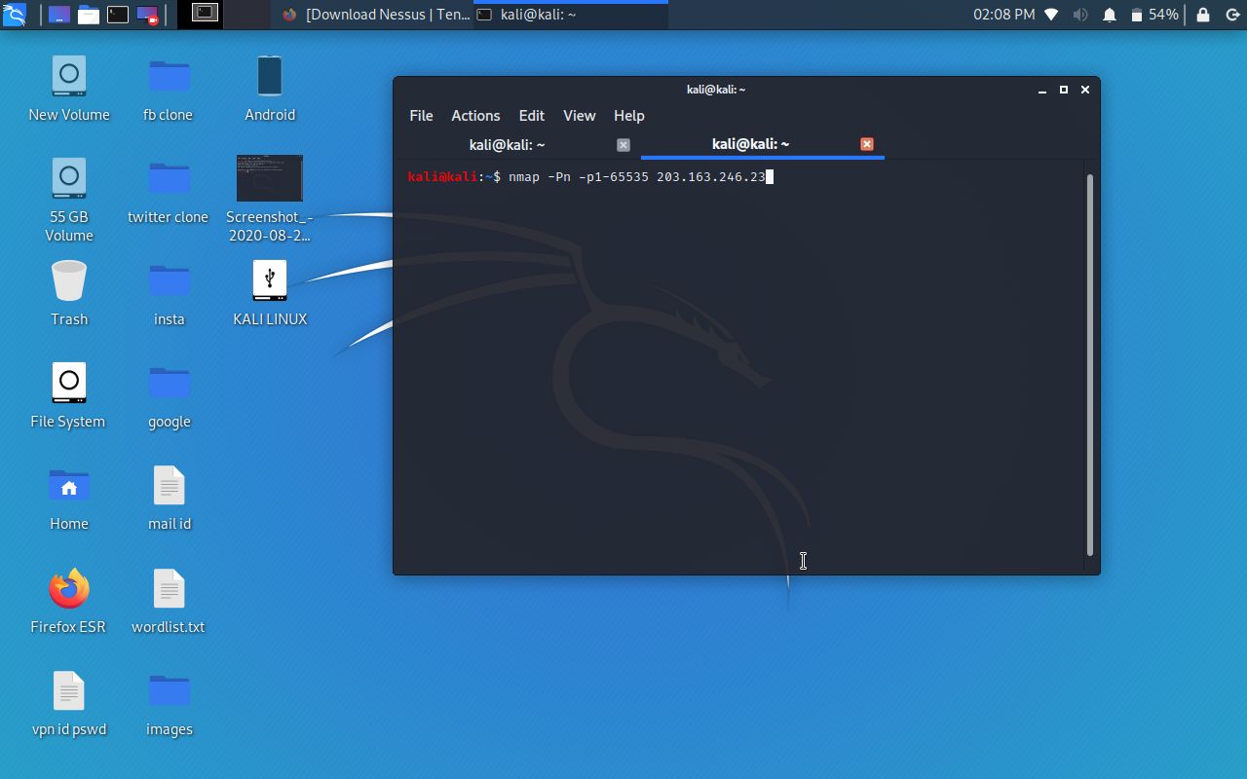

3rd- Conclusion was no open port was found. All the ports are Filltered or Firewall Enabled in this System.
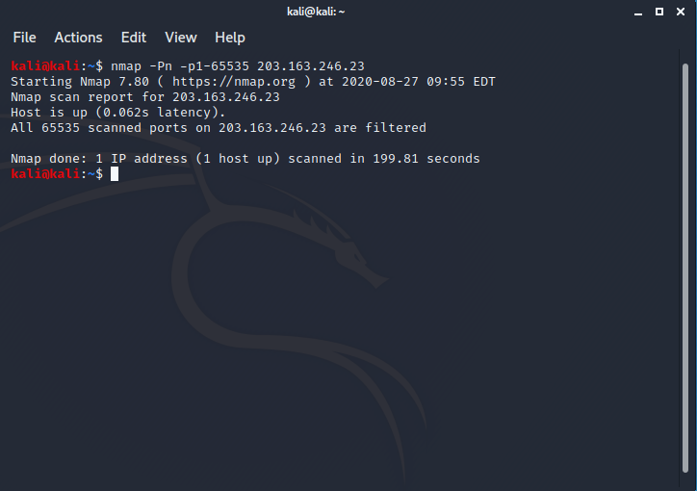

Made by: Abhishek Kumar
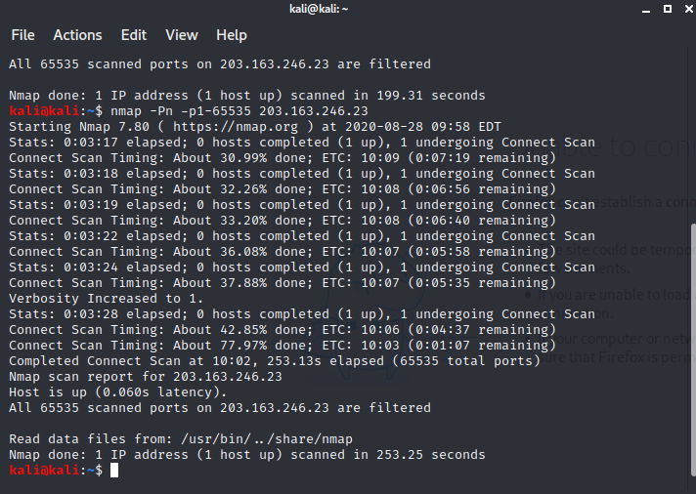
4th- While trying another method to Search for open port:-
Typed: “nmap -Pn -sS 203.162.246.23”
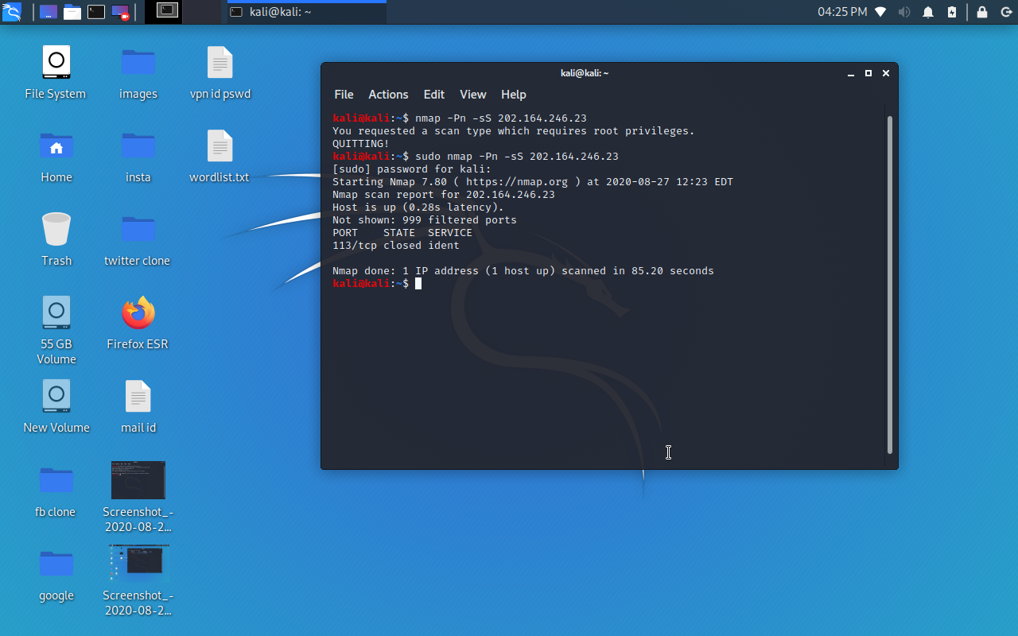

Found: The port has been Filltered / Firewall Enabled
PORT STATE SERVICE
113/tcp Closed ident

Made by: Abhishek Kumar

